Volunteering for
Shuttlewood Clarke Foundation
Individual Volunteering: Bringing fun and fulfillment to your life
If you are interested in volunteering please come along to one of our recruitment days where you will have the opportunity to find out more about the history and work of this wonderful charity and the different volunteering roles we have to offer.
Dates for 2015: Monday 26th January, Thursday 23rd April, Thursday 23rd July, Thursday 22nd October. Commencing with a presentation at 10.00 a.m. all our recruitment days will take place at Ulverscroft Manor, Priory Lane, Ulverscroft, Leicestershire, LE67 9PH.
“I find volunteering for Shuttlewood Clarke very enjoyable, fulfilling and rewarding. I have learnt a lot over the years, particularly in catering, and hope to carry on for as long as possible.” Paul (SCF Volunteer)
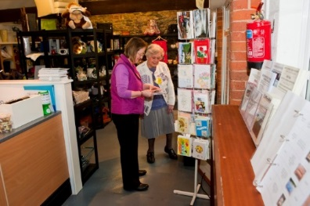
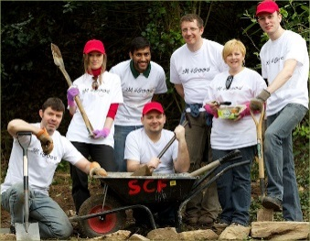
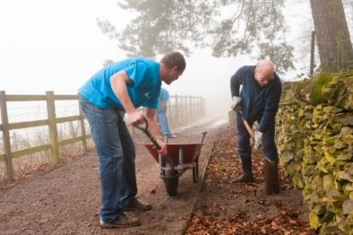

Corporate Volunteering: Escape the office and enjoy learning new skills with your team!
The Foundation can offer volunteering opportunities for our corporate partners in maintenance and fundraising. To find out more about corporate volunteering please contact us to discuss your organisation’s requirements in more detail.
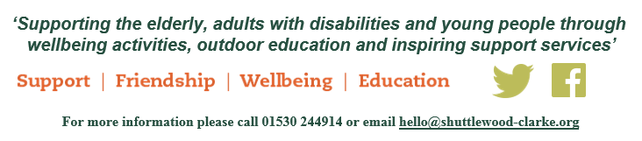
“It was a bit different to how I normally spend a working day, but it was enjoyable and really worthwhile.” Sarah (Corporate Volunteer)

